Exp.No-2

2. Perform basic Image Handling and processing operations on the image
• Read an image in python and Convert an Image to Blur using Gaussian Blur.

Aim:
To apply Gaussian Blur to an image using OpenCV.

Procedure:
- Start the program.
- Import the OpenCV library.
- Read the input image.
- Apply Gaussian Blur.
- Display the original and blurred images.
- Save the blurred image.
- Stop the program.
Program:
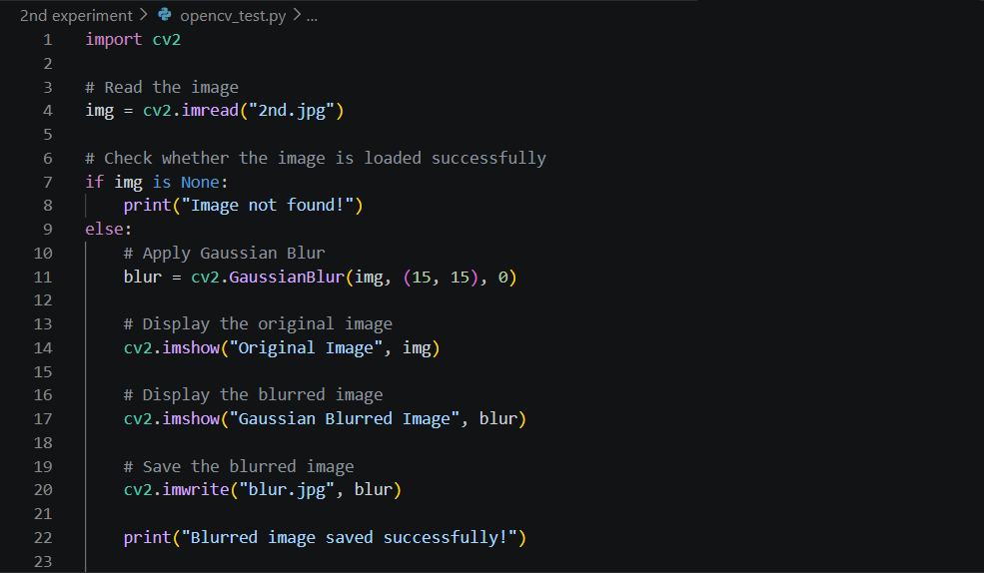
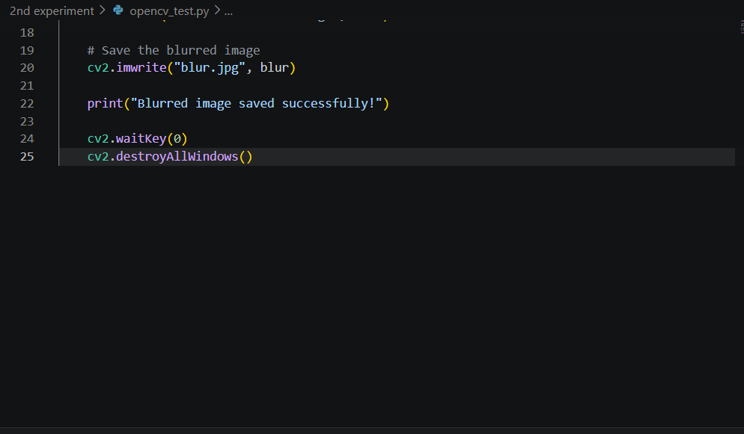

Input:

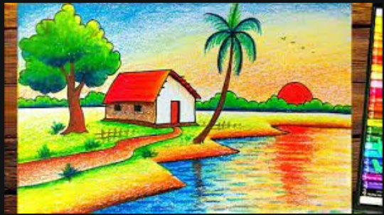


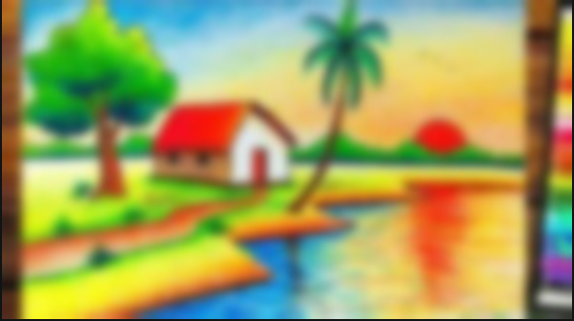
Output:

Result:
The input image was successfully blurred using the Gaussian Blur technique and displayed.

